**PROJECT NAME: SPOTIFY**

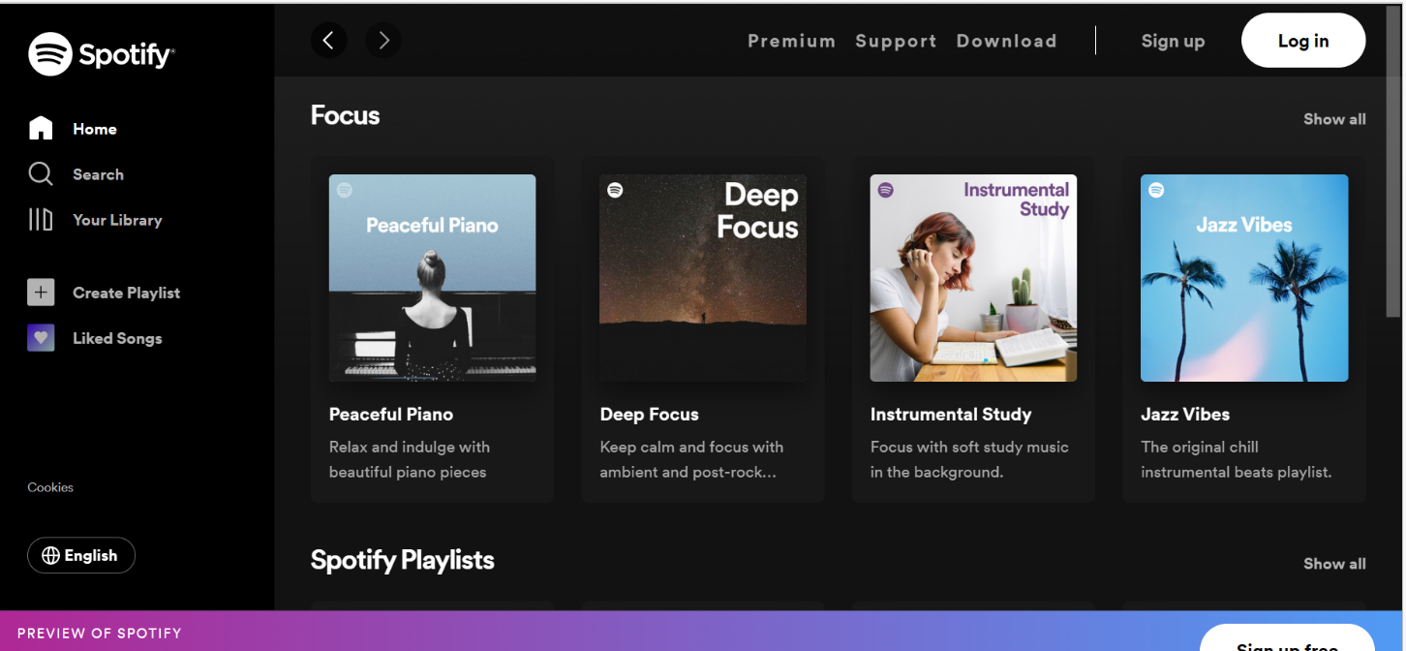

**OVERVIEW:**

Spotify is a**digital music streaming service**. It gives you instant access to its vast online library of music and podcasts, allowing you to listen to any content of your choice at any time. It is both legal and easy to use.

**GOALS**

1. HOME PAGE

2. PREMIUM PAGE

3. SUPPORT PAGE

4. DOWNLOAD PAGE

5.LOGIN PAGE

6. SIGN UP PAGE

7.COMMUNITY PAGE

1. **HOME PAGE:**

# LOGO

# ICONS

# SEARCH BAR

# YOUR LIBRARY

# CREATE PLAYLIST

# LIKED SONGS

# COOKIES

# CHOOSE A LANGUAGE(FROM ALL THE LANGUAGES)

# SLIDERS WITH ARROWS - (IMAGES)

# FOCUS

# FEATURED - (MUSIC WITH IMAGES)

# TRENDING - ( MUSIC WITH IMAGES )

# SPOTIFY PLAYLIST

# FOOTER – ( PREVIEW OF SPOTIFY,SIGN UP FREE )

1. **PREMIUM PAGE :**

# LOGO

# GET STARTED BUTTON, SEE OTHER PLANS BUTTON

# THE POWER OF PREMIUM

* Ad-free music listening(with logo)
* Offline playback(with logo)
* Play everywhere(with logo)
* Pay your way(with logo)

# PICK YOUR PREMIUM

* LOGOS
* MINI PLAN
* INDIVIDUAL PLAN
* DUO
* FAMILY

# SPECIAL DISCOUNT FOR ELIGIBLE STUDENTS IN UNIVERSITY

* LEARN MORE (BUTTON)

# FOOTER

* COMPANY
* ABOUT
* JOBS
* FOR THE RECORD

# COMMUNITIES

* FOR ARTISTS
* DEVELOPERS
* ADVERTISING
* INVESTORS
* VENDORS

# USEFUL LINKS

* SUPPORT
* WEB PLAYER
* FREE MOBILE APP
* SOCIAL SITE LOGOS
* LANGUAGE
* LEGAL
* PRIVACY CENTER
* PRIVACY POLICY
* COOKIES
* ABOUT ADS

1. **SPOTIFY SUPPORT PAGE:**

# LOG IN - ( PAYMENT HELP,PLAN HELP, APP HELP,DEVICE HELP,SAFETY & PRIVACY,ACCOUNT HELP )

# IMAGES OF THE CHOSEN HELP

# QUICK HELP

* CAN’T RESET PASSWORD

(HOME,ACCOUNT HELP,RELATED ARTICLES,)

* CAN’T REMEMBER LOGIN DETAILS

(VEDIO FOR HELP)

* FACEBOOK LOGIN HELP
* PAYMENT METHODS
* START OR JOIN PREMIUM FAMILY
* VISIT OUR COMMUNITY(GO TO COMMUNITY BUTTON)

COMMUNITY PAGE OPEN

1. **:COMMUNITY PAGE**

# SEARCH,HOME HELP,HELP WIZARD,FAQs,ONGOING ISSUES

# FAQs - (APP HELP WITH VIEW ARTICLES BUTTON,PLAN HELP,PAYMENT HELP,DEVICE HELP,ACCOUNT HELP,COMMUNITY HELP,SUGGESTED ARTICLES,FOOTER)

**5.:DOWNLOAD PAGE**

# ICON,DOWNLOAD BUTTON,DOWNLOAD STORES ICON AND BUTTON)

# ONE ACCOUNT,LISTEN EVERYWHERE

(MOBILE,COMPUTER,TABLET,CAR,PLAYSTATION,XBOX,TV

SPEAKER,WEB PLAYER,FOOTER,SOCIAL MEDIA LINKS)

**5.:SIGN UP PAGE**

# SIGN UP WITH FACEBOOK

# SIGN UP WITH GOOGLE

# SIGN UP WITH YOUR PERSONAL DETAILS

**6.:LOG IN PAGE**

# CONTINUE WITH FACEBOOK

# CONTINUE WITH APPLE

# CONTINUE WITH GOOGLE

# CONTINUE WITH PHONE NUMBER

# OR BHY PERSONAL DETAILS

**TECHNOLOGY USED IN SPOTIFY**

**Front-End:**

1. Html

2. CSS

3. Bootstrap

4. React

**Dynamic:**

1. JavaScript

2. Ci/cd with AWS

3. Login and Logout (oauth and jwt)

**Database:**   
1. Mongo dB

2. Json Data

**Code compilers:**

1. Visual studio code

2. Git bash

3. Git hub

4. Node js

**GITHUB LINK:**